**Assignment 4**

1) For the 1st question the file has been encrypted using a crypto code.

To the script given to us add a line mycrypto("q1.png.enc") and run it.

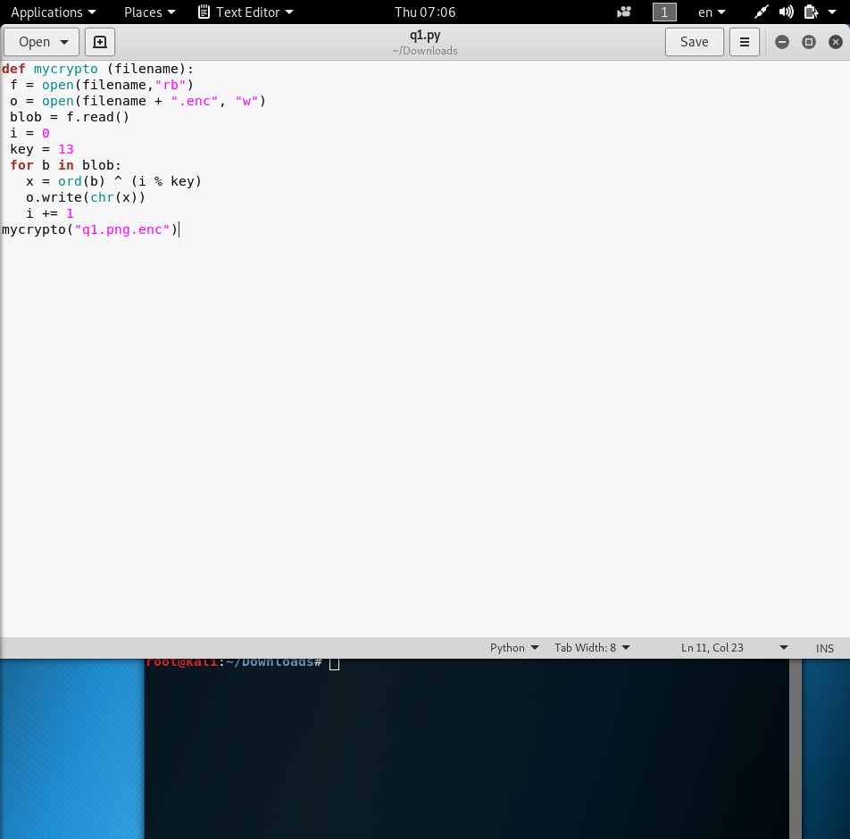

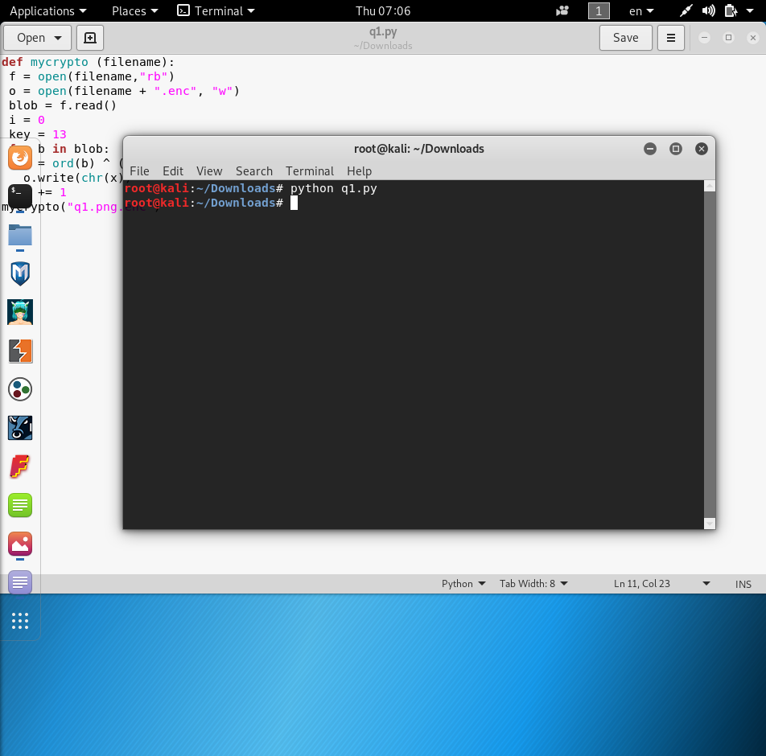

This will decrypt the file and shows the secret:

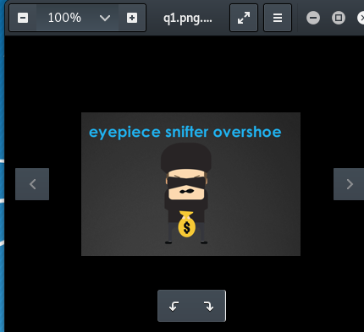

2) For this question I used code given in workshop 4. Along with this used import binascii and plain = binascii.unhexlify("%x" % plain). After this I ran the script to get the result.

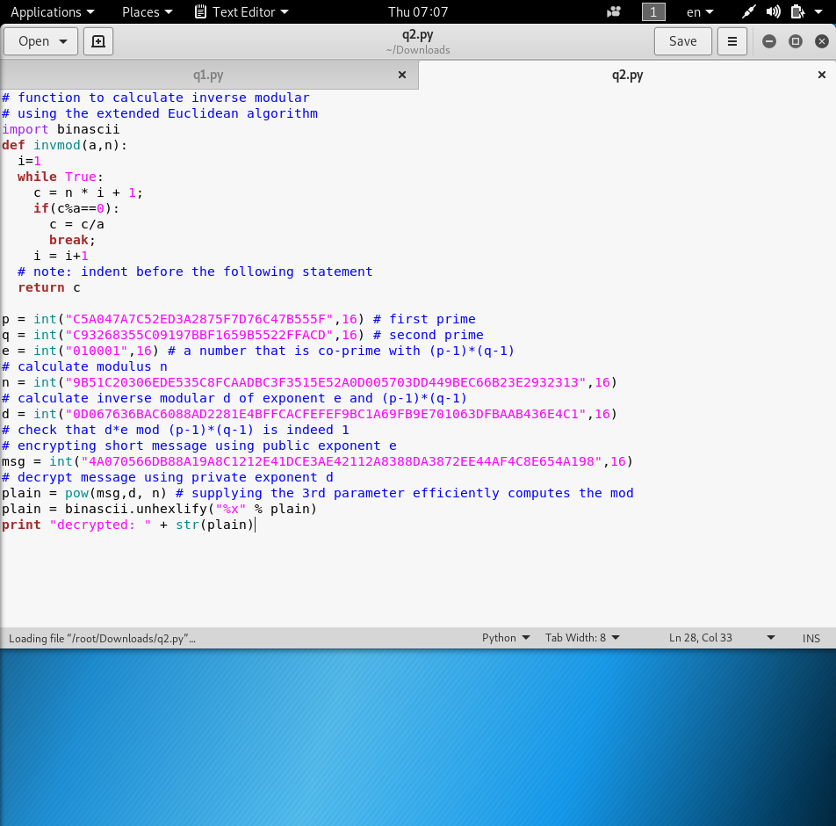

The answer is Cowwanbanga!

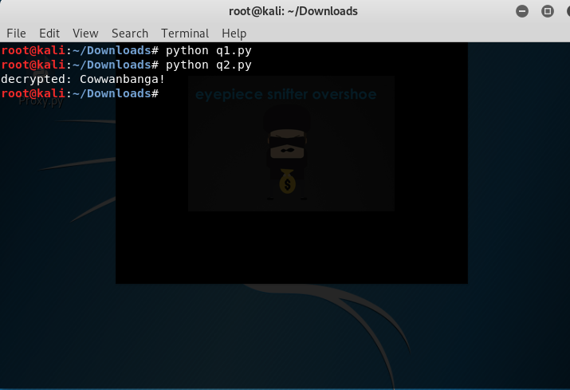

3) For this question i searched on google for a 1024*768 size bmp image. I chose the picture and saved it my computer as pic.bmp.

Then I used the command dd if=pic.bmp count=54 ibs=1 >> out.bmp and dd if=secret_16bit_1024x768_ecb.bmp.enc skip=54 ibs=1 >> out.bmp to find the hidden message at out.bmp which is cyber.

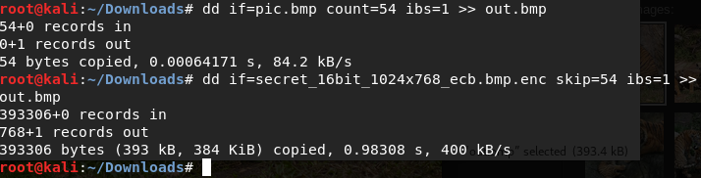

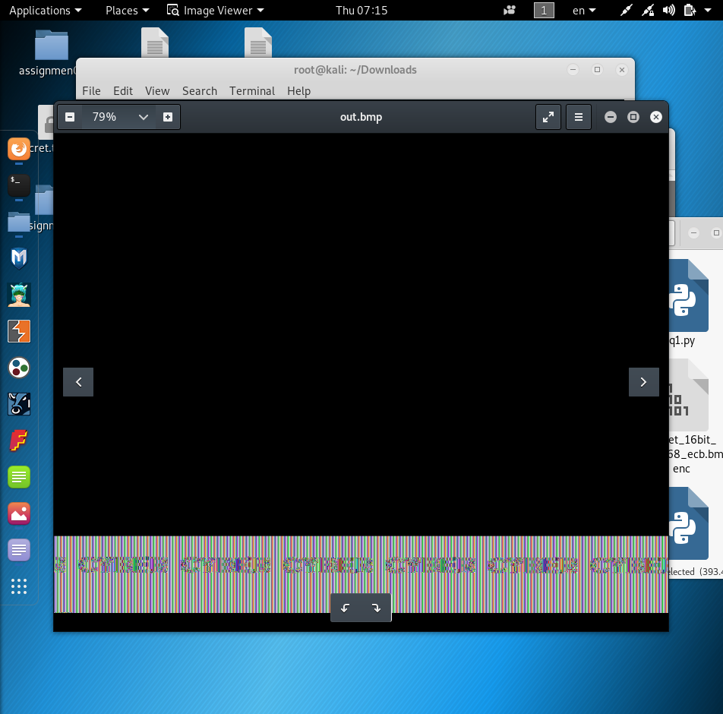

4)

For this question I used a tool to find the frequency analysis



I change the most frequent letter on the text.

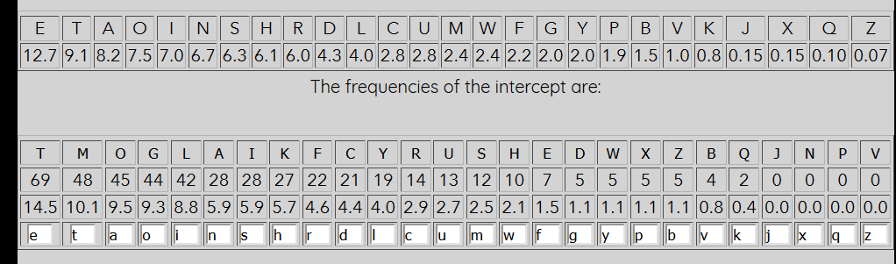

The key:

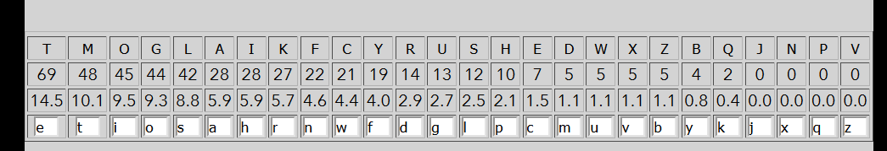

The deciphered text:

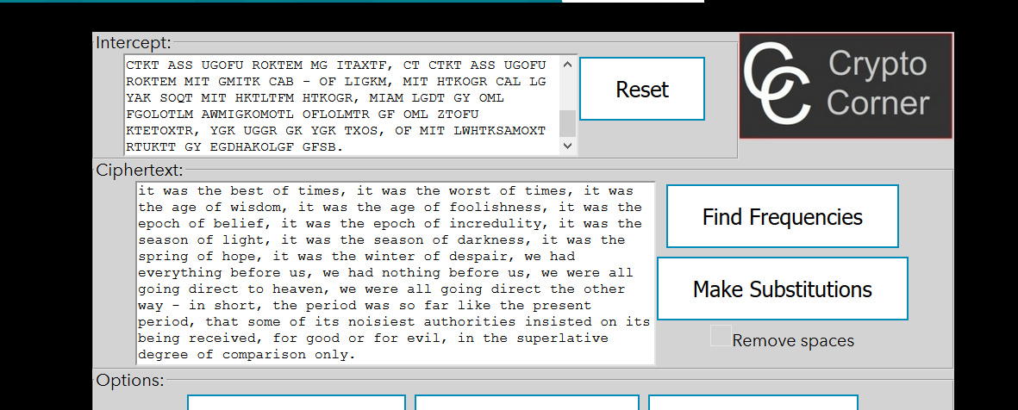

5)

First I download the file and then also create a file called input.txt in the same directory. Then I used the command hashcat -m 500 -a 0 -o input.txt shadow1 /usr/share/wordlists/rockyou.txt -O --force and this runs for about 42minutes approximately.

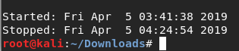

And input.txt has password : pretzels

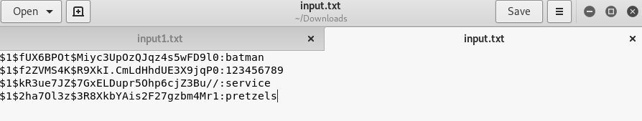

After this use ssh superman@10.0.0.32 and then do then do ls-a and then we find file called .secret and then use the command vim .secret to get the secret:

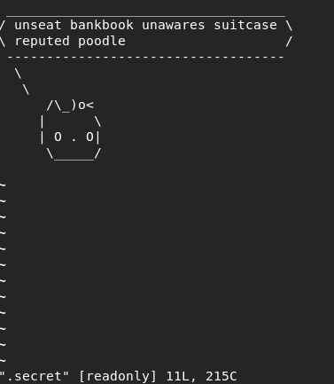

6)

First I download the file and then also create a file called input1.txt in the same directory. Then I used the command hashcat -m 1800 -a 0 -o input1.txt shadow2 /usr/share/wordlists/rockyou.txt -O --force and this runs for about 22minutes approximately.

Macintosh HD:Users:admin:Desktop:Screenshot 2019-04-05 at 6.28.36 PM.png

This the password in input1.txt:

